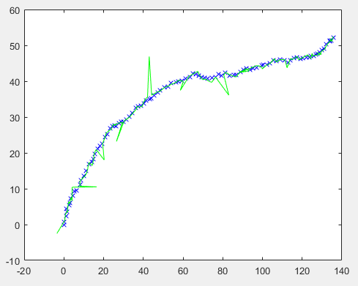

Figure: initial plot values for csv files.

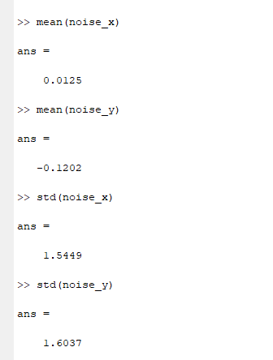

Mean values

noise_x= 0.0125

noise_y= -0.1202

standard deviation values

std (noise_x)= 1.5449

std (noise_y)= 1.6037

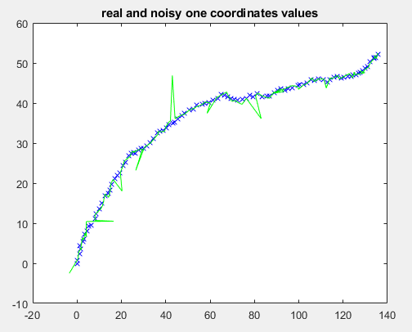

Figure: task1 real and noisy ones co-ordinates

Using kalman filter

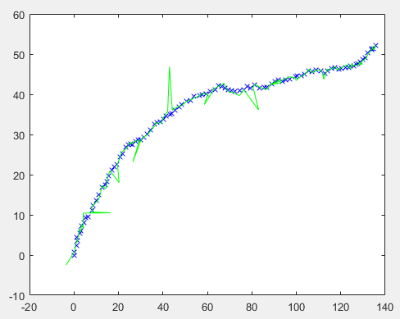

Plotting the values for x,y and m,n

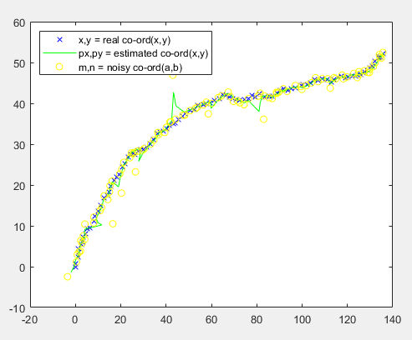

Figure: final comparison of both noisy and estimated co-ordinates of ground truth.

**Task 2**

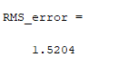

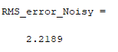

Std_dev_absolute_error_Noisy =

Columns 1 through 13

4.2636 0.5137 0.7959 0.7844 0.8944 0.9444 0.2816 0.4697 1.4575 1.5510 10.2403 0.3538 0.6284

Columns 14 through 26

0.6990 0.5912 0.4956 1.0521 0.0510 0.3094 0.8707 4.5120 0.2391 0.6860 0.6055 0.6874 0.5310

Columns 27 through 39

0.5084 1.0818 0.3014 0.6191 6.4902 1.1163 0.4496 0.0742 0.5679 0.8979 0.5315 0.3437 0.7608

Columns 40 through 52

1.1415 11.6937 1.1958 0.2532 0.4300 0.0862 0.5469 0.5241 0.2055 0.4691 0.6988 4.0858 0.4249

Columns 53 through 65

0.7968 1.0869 0.3714 0.7229 0.8198 0.5204 1.2074 0.1942 7.6873 1.0126 0.4243 0.2607 0.3840

Columns 66 through 78

0.5922 0.2197 0.8393 0.3761 0.4539 6.4437 0.5935 0.3064 1.3565 0.2452 0.4491 0.6114 0.2732

Columns 79 through 91

0.0703 0.3621 1.6389 0.5503 1.2227 0.3173 1.0508 0.3736 0.9207 0.8770 1.0939 0.5504 2.8156

Columns 92 through 100

0.3491 0.5019 0.2324 0.4271 0.4371 0.6085 0.5237 0.3538 0.4596

Std_dev_absolute_error =

Columns 1 through 13

2.4053 1.0749 1.2108 0.6175 1.0551 0.5304 0.4560 0.2869 1.2670 0.9367 5.3628 1.9391 0.6454

Columns 14 through 26

0.4075 0.7004 0.4651 0.6473 0.2465 0.2898 0.9043 2.5908 0.8866 1.0102 0.4537 0.3128 0.4222

Columns 27 through 39

0.7920 0.9588 0.6668 0.3174 3.5283 2.2580 0.9481 0.6356 0.6134 0.4853 0.0758 0.2496 0.5256

Columns 40 through 52

1.0061 7.5213 3.4893 1.5893 0.3723 0.3821 0.3957 0.4087 0.5971 0.4130 0.4712 2.3389 1.2956

Columns 53 through 65

1.1722 0.4262 0.7607 0.4148 0.7137 0.4155 0.8191 0.5450 4.9231 2.4130 1.3064 0.2530 0.1498

Columns 66 through 78

0.4194 0.3280 0.6874 0.4536 0.4055 3.9725 2.0580 1.1355 0.9655 0.4214 0.2847 0.1545 0.4418

Columns 79 through 91

0.0266 0.3898 0.5810 0.0770 0.8634 0.1380 0.6768 0.2507 0.4129 0.7438 1.2331 0.2923 1.9200

Columns 92 through 100

1.1469 0.5782 0.5190 0.5812 0.8339 0.3839 0.7147 0.4934 0.1747

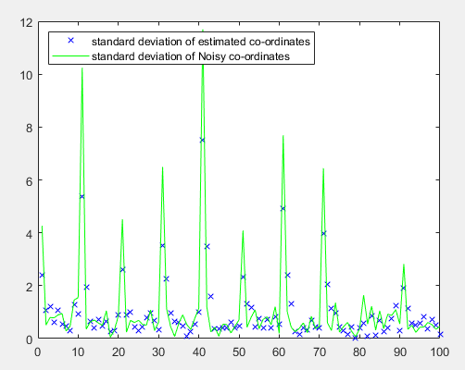

Final plot for noisy co-ord with estimated co-ord( comparision)